JFSD: A-Z of Back-end and Database Development
Day 3 : 20 Jul. 24

Polymorphism
One name many forms or many implementation
Types of polymorphism
2 types
- Compile time polymorphism
Or Static binding
Or early binding
Example : Method overloading : method have same name but different parameter list ie type of parameter list or number of parameter list must be different.
- Run time polymorphism
Or late binding
Or dynamic binding
Example : Method Overriding :
The method have same name and same method signature (number of parameter list, type of parameter list and return type must be same). To achieve method overriding we need min two classes with inheritance.

Annotation : Annotation is like a meta-data. Meta-data means data about data. Java provided lot of pre defined annotation like decorator in angular. Few annotation we can use on class level or method level or property/variable level
Core Java annotation
@Override : this annotation we have to use on method level. If method overriding then there is not compile time error else it show error.

abstract keyword
- abstract is a keyword we can use with method and class but not with variable.
- Abstract method : method without body or without curly braces or incomplete method is known as abstract method
abstract returnType methodName(parameterList);
abstract void speed();
- If class contains abstract method that class must be declared as abstract.
- Whichever class extends abstract class that class must be provide body for all abstract method mandatory.
- Abstract class can contain normal as well as abstract method means it can contains 0 or 1 or all abstract methods.
- If class is abstract but no abstract method what is the use. Abstract class we can’t create the object.
final keyword
- Final keyword we can use with variable, method and class
- Final variable. To declare constant variable in java we use final keyword.
Example : final int A=10;
A=20; error
- final method : if method is final sub class can’t override that method but it can use it.
- final class : can’t inherits or sub class.

static keyword
- static keyword we can use with variable and method but not with class.
- static variable : if variable is a static we can access this variable with help of class name object not required.
- Static method : if method is static we can call that method with help of class name object not required.
- We can call static method with help of class name as well as object. we can assign the value for static variable with help of class name as well as object also.
- Inside static method we can access only static variable directly but inside non static method we can access both static as well as non static directly.

Static is like a global to all object like mgrid, clientid, trainerid etc

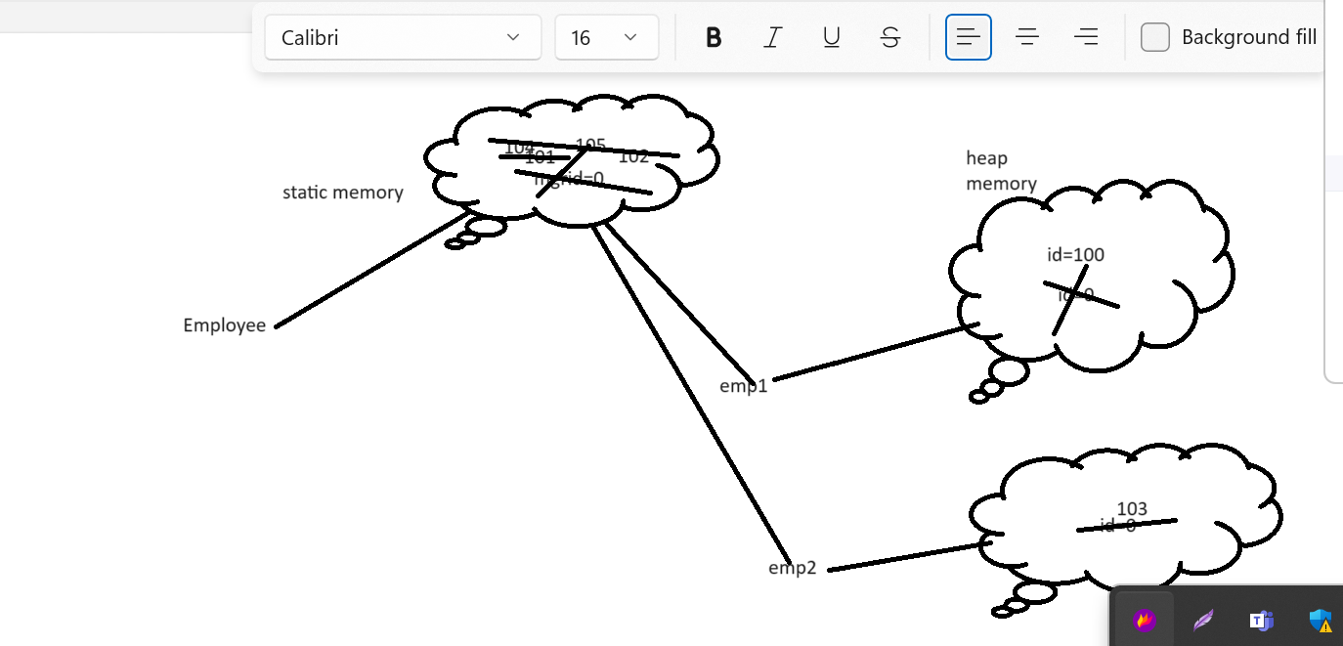

Interface : Interface is a type of reference data type which is also known as 100% pure abstract class.

Syntax
interface interfaceName {
fields;
methods;
}
All fields or variable part of interface by default public, static and final
All method inside a interface by default public and abstract

interface Abc {
public static final int A=10;
static final int B=20;
final int C=30;
int C=40;
int D; Error
public abstract void dis1();
abstract void dis2();
void dis3();
void dis4() {} Error
}
interface Abc {
int A=10;
void dis1();
}
interface Xyz {
int B=20;
void dis2();
}
interface Mno extends Abc,Xyz{ we can achieve multiple inheritance
int C=30;
void dis3();
}
class Demo implements Abc, Xyz { we can achieve multiple inheritance.
Provide the body for dis1() and dis2();
}
One interface can extends more than one interface. But class can extends only one class.
Class always implements interface. Class can implements more than one interface. Whichever class implements any interface that class must be provide body for all abstract method belongs to those interface.

Difference between interface and abstract methods
- Abstract class can contain normal method as well as abstract method. but interface contains only abstract methods.
- Abstract class can contain normal as well as final variable. But interface contains only final variable.
- Abstract class can contains default constructor as well as we can write parameterized constructor. But interface doesn’t default as well as we can’t write parameterized constructor.
- Normal class can extends only one abstract class But normal class can implements more than one interface.
- Which class extends abstract class as well as interface that class must be provide the body for all abstract method belongs to that interface or abstract class mandatory.
- Using interface we can achieve 100% abstraction but using abstract class we can achieve partial abstraction.

Common points
- We can’t create the object of interface as well as abstract class.

Packages and access specifiers
Package : package is a collection of classes and interface. Which more than one class as well as interface which have same name but different purpose. Using package we can avoid that conflicts. Package is a like a directory or folder.
Package divided into two types.
- User defined package
education
school college
Attendance Attendance

Access specifiers : Using access specifiers we can expose the visibility of classes, variable, method and constructor from same package to other packages.
Java provided totally 4 types of access specifiers
- private
- using : we can use private access specifiers with instance variable, static variable, non static method, static method and constructor but we can’t use with local variable as well as class.
- scope : within a same class.
- default or nothing
  - using : we can use with all.
  - Within a same package
- protected
  - using : we can use protected access specifiers with instance variable, static variable, non static method, static method and constructor but we can’t use with local variable as well as class.
  - within a same package as well as other package if sub class.
- public
  - using : we can use private access specifiers with instance variable, static variable, non static method, static method, class and constructor but we can’t use with local variable.
  - Same package as well as other package.

- Pre defined package.

